# CS 255 System Design Document Template

This template lays out all the different sections that you need to complete for Project Two. Each section has guidance to prompt your thinking. You will need to continually reference the interview transcript as you work to make sure that you are addressing your client’s needs. There is no required length for the final document. Instead the goal is to complete each section based on what your client’s needs are. Remove this note when you are finished, and replace all bracketed text with the relevant information.

## UML Diagrams

### UML Use Case Diagram

*[In Module Six, you were asked to complete a use case diagram based on your system design. If you would like to make any adjustments to your diagram, please do so. Please insert your use case diagram here. Check to make sure that you included appropriate components and symbols and that your design meets the client’s needs.]*

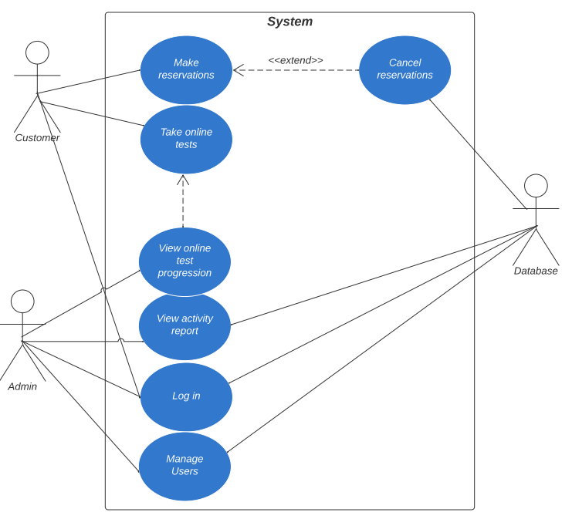

### UML Activity Diagrams

*[You were asked to choose* ***two*** *use cases and create* ***two*** *activity diagrams, one for each use case. Please insert* ***both*** *of your activity diagrams here. Check to make sure that you included appropriate components and symbols and that your design meets the client’s needs.]*

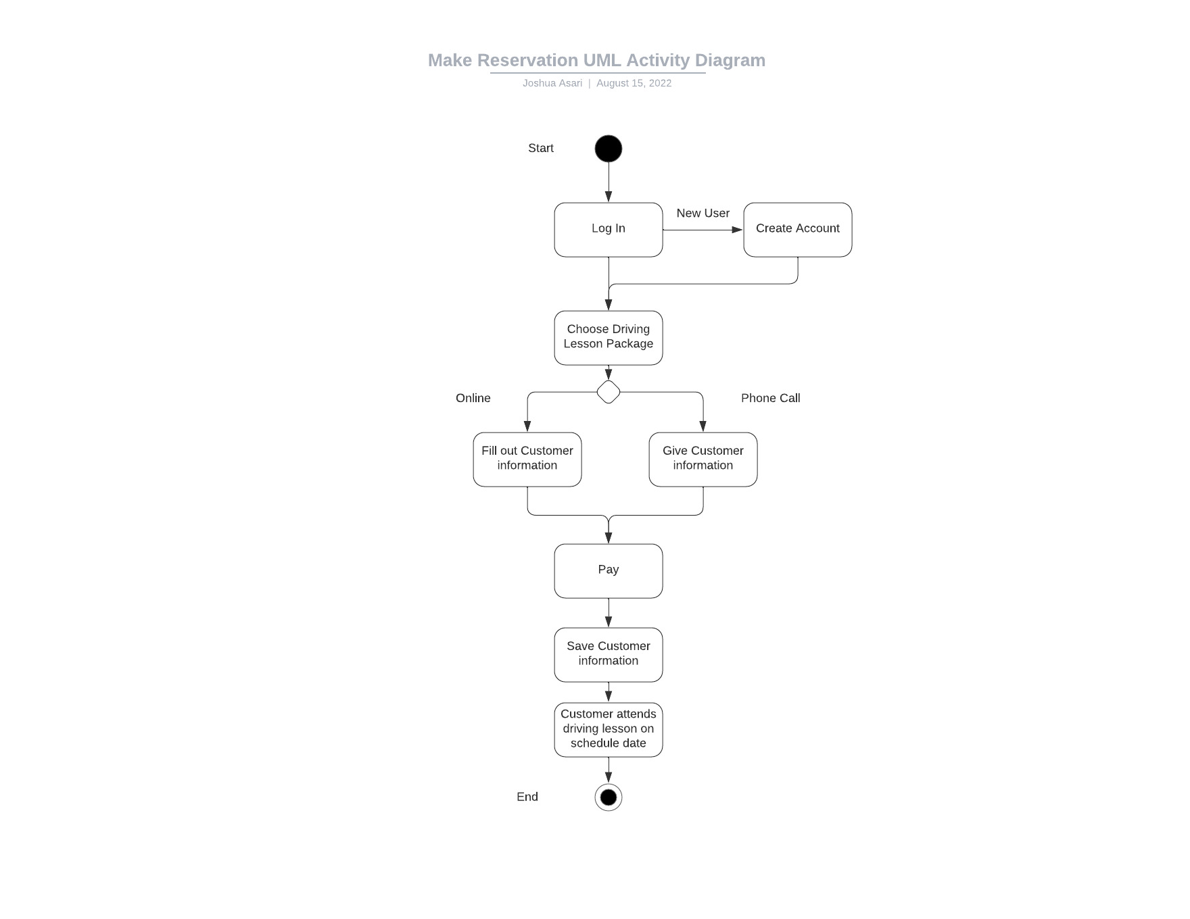

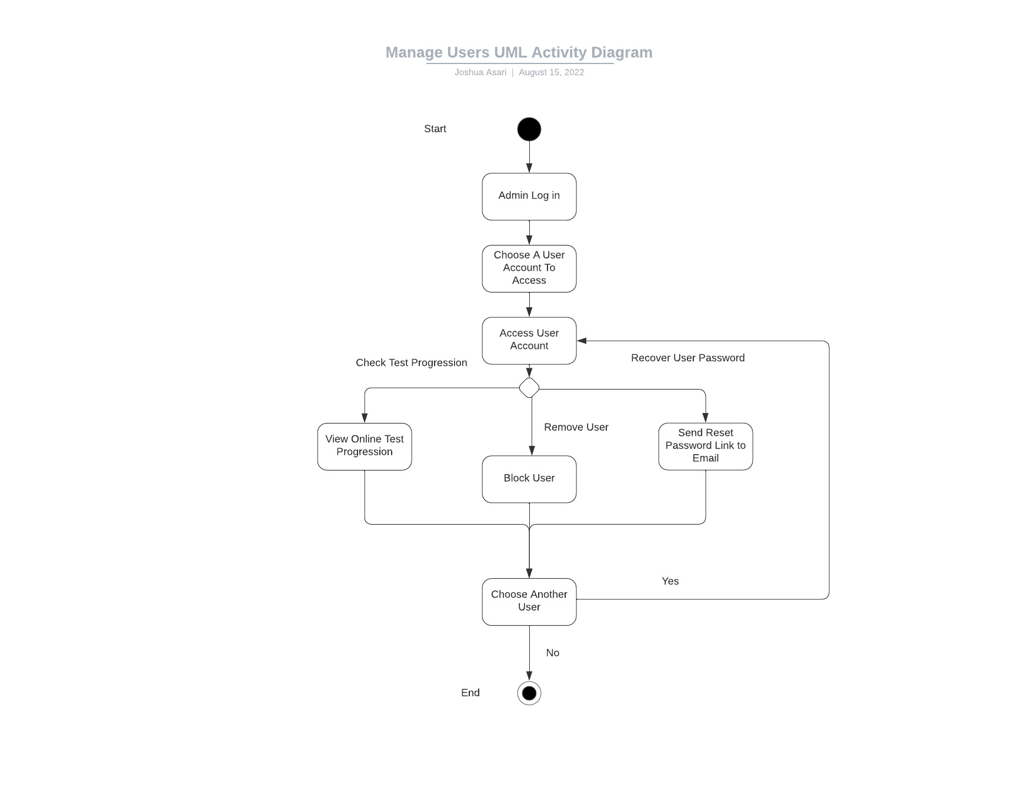

### UML Sequence Diagram

*[You were asked to create a sequence diagram based on* ***one*** *of the use cases you chose. Please insert your sequence diagram here. Check to make sure that you included appropriate components and symbols and that your design meets the client’s needs.]*

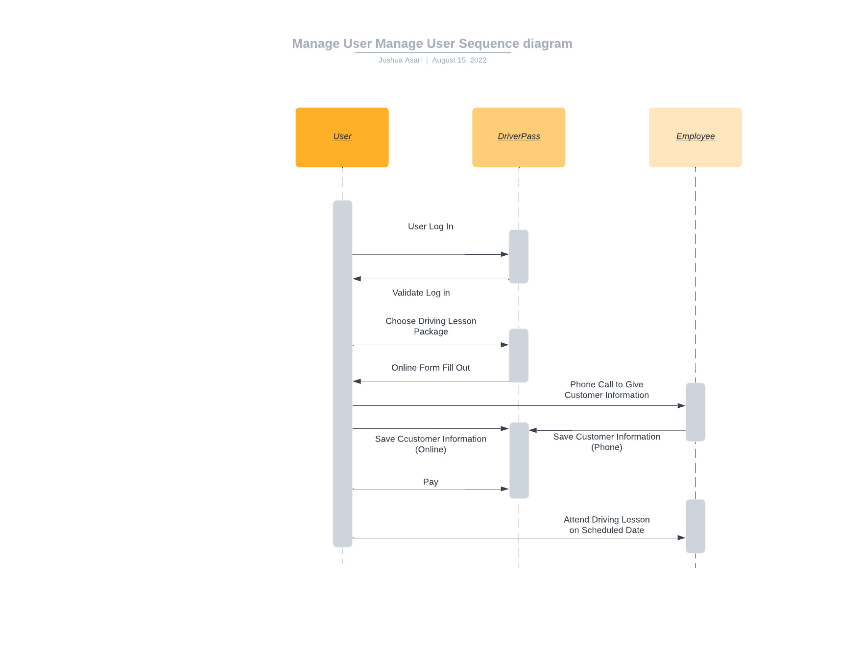

### UML Class Diagram

*[You were asked to create a class diagram based on the different classes and attributes needed for your system design. You are* ***not*** *required to include methods, but you may if you wish. Please insert your class diagram here. Check to make sure that you included appropriate components and symbols and that your design meets the client’s requirements.]*

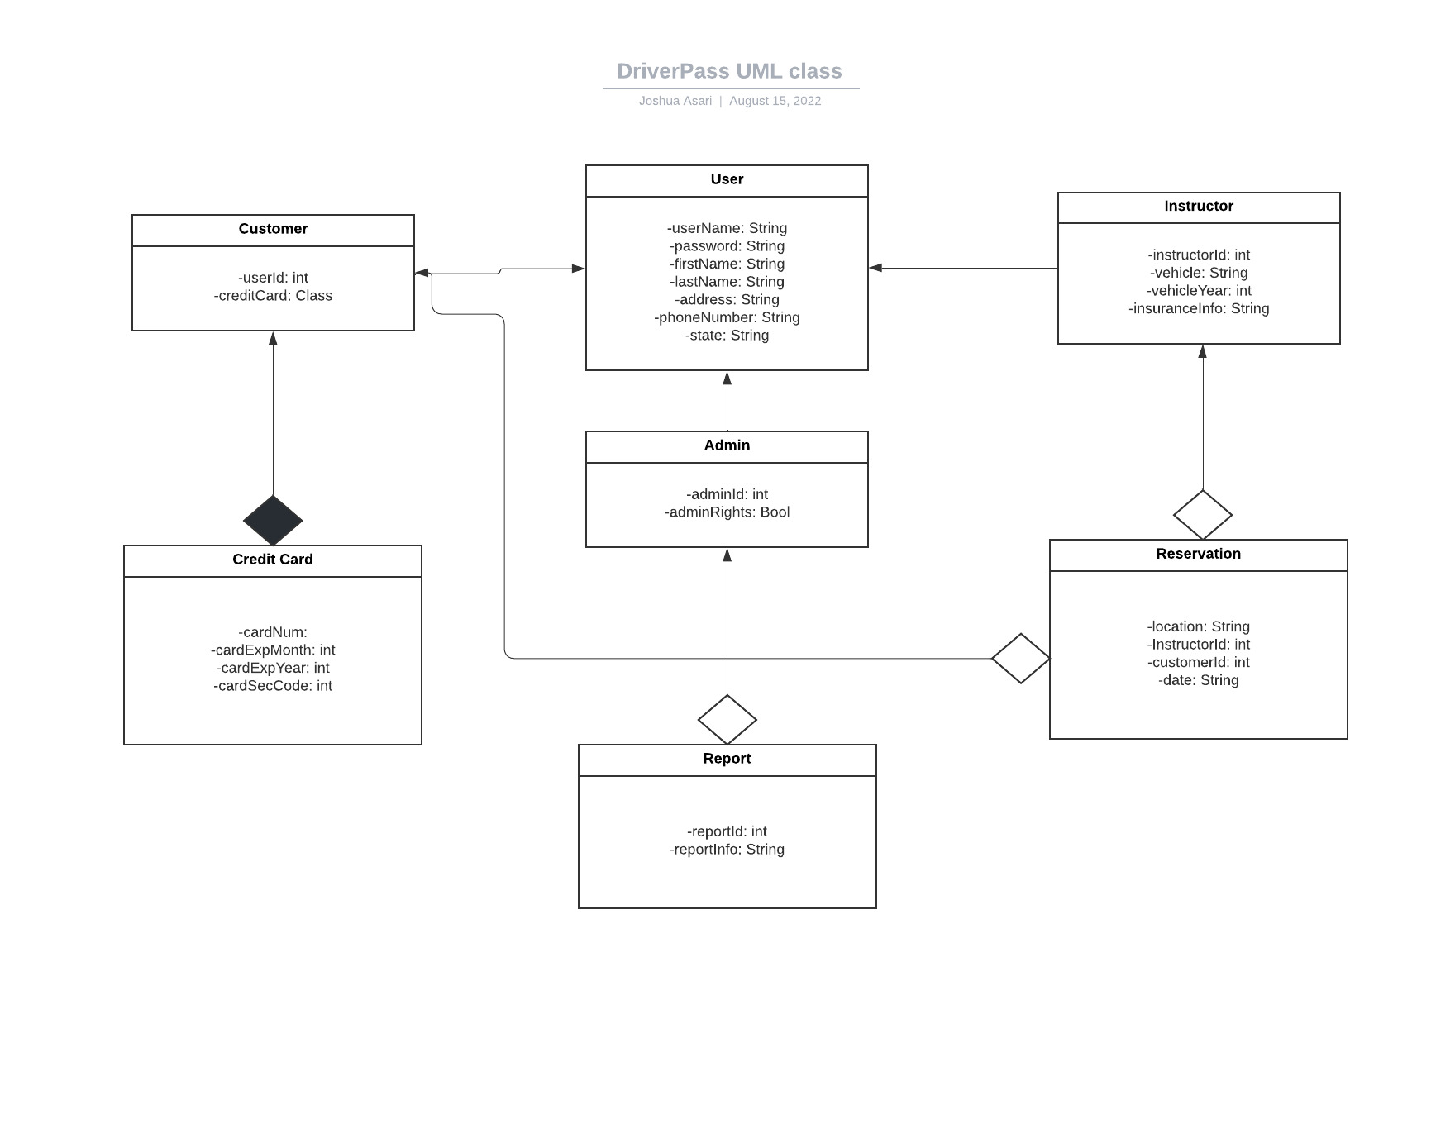

## Technical Requirements

*[Based on the diagrams you have created, describe the technical requirements of your system. These requirements should address the required hardware, software, tools, and infrastructure necessary for your system design.]*

Based on the diagrams created, there are many technical requirements within the system. First of all, DriverPass' hardware requirements are that they will need Computers for their admins to be able to work while on location. No servers are needed as their services will be hosted on the cloud, thus there are no such need for server equipment. Just an internet provider and any hardware that allows them to use a computer / navigate one.

On the other hand, the hardware requirements for the customer are that they also have a working computer that is connected to their WiFi. Lastly, any hardware that allows them to use and navigate a computer such as a mouse / keyboard / power.

The Software requirements for DriverPass is that they have their DriverPass Software code base. Also, since their database is stored within the cloud, DriverPass can use Node.js as their framework of choice to build DriverPass in the cloud. DriverPass should also have any software security installed as well.

For the customer, their Operating System should either be Mac OS or Windows. Linux is not an option as DriverPass will not be updating the website for Linux because of budget constraints. Next, a web browser should be installed such as Chrome or Firefox.

Lastly, the infrastructure necessary for the system design is that the system will be run on cloud services.